|  |  |  |
| --- | --- | --- |
| **Problem Chosen** D | **2020 MCM/ICM Summary Sheet** | **Team Control Number** 2010905 |

Teamwork Analysis From Football to Society

In order to search for the best strategy for teamwork, we first establish the **Compactness Model Based on Passing (P-C Model)**,with the assistance of which we successfully establish the Dynamic Compactness Network for passing between players. The network is able to reflect the directional connections between players on the field in real time, thus making it possible to provide a lot of information such as network model,personal tactical value, team strategy and so on.Taking advantage of this network and previous research and data, we establish the **AODC Model** which help us summarize four performance indicators of teamwork and the evaluation factors of each performance indicator which can judge the relationship between team strategy and opponent strategy and the nature of the team itself.

In the P-C Model, we establish multiple sub-models and indicators for the final Dynamic Compactness Relationship Network.We quantify the impact of each passing on player relationships to construct the Real-time Compactness Function so as to be able to reflect the compactness between players.For the sake of being able to identify the network model and reflecting the team's team strategy over a period of time, we modified this function and proposed the Compactness Function.Considering the impact of individual abilities on the team , we put forward the Player Ability model to judge the value of players in the team's strategy. Next, we predict the player's movement direction and speed on the court, and successfully use Matlab to simulate the movement of all players on the court to form real-time motion trajectories.Eventually, we use the movement position as the position of the node, and the Compactness between the two as the weight of the arc, and establish a dynamic closeness relationship network, which can draw the current network relationships of the team's current strategy and tactics, and the connections between players.

In the AODC model, we select four performance indicators that reflect successful teamwork.Under the Pareto's Law ,We select a limited number of representative factors, and analyze values of these factors from the data .Owing to the fact that dimensions of each factor value are different, we normalize each factor value.We use the Analytic Hierarchy Process to construct the coefficient matrix. After calculating the weight value of each factor on the performance index,we calculated the performance index scores of multiple teams including the Huskies, which not only verified the accuracy of the model, but also reflected the Husky team's ability in four aspects this season.Focusing on adaptability and comparing the other three performance indicators of the opposing team, we can understand the team's ability to respond to strategic changes, and propose that the effectiveness of the strategy is related to the anti-strategy to a certain extent.

Finally, based on the above two models, we establish 6 evaluation criteria for the Excellent teamwork, and give a method for designing and evaluating teams with models, and proposed data that needs to be captured in order to develop a general model of team performance. As a conclusion, we write a letter to the management of the Eskimo team and provide opinions based on our analysis of the team .Apart from this, We wrote an extremely complicated program to get the offensive heat map of the Huskies team this season, through whitch the management can more clearly find the internal problems of the team.

**Key Words:**real-time motion trajectories, Dynamic Compactness Network, Analytic Hierarchy Process, offensive heat map throughout the season.

**Contents**

**1 Introduction 1**

1.1 Restatement of The Problem 1

1.2 Literature Review 1

1.3 Our Work 1

**2 General Assumptions 2**

**3 Compactness Model Based on Passing（P-C Model） 3**

3.1 Basic Structure of The Model 3

3.2 Compactness Indicator 4

3.2.1 Passes Index 4

3.2.2 Pass Distance Index 5

3.3 Model of Player Ability 6

3.4 Model Optimization 6

3.5 Dynamic Compactness Network 7

3.5.1 Establishment of Dynamic Compactness Network 7

3.5.2 Network Pattern Recognition 8

3.6 Model Evaluation And Sensitivity Analysis 9

**4 AODC Model 11**

4.1 Coordination 12

4.2 Adaptability 13

4.3 Offensive 13

4.4 Defensive 14

4.5 Normalized Calculation of Factors 14

4.6 Weight Calculation 15

4.7 Simulation 16

**5 Build An Effective Team** 17

**6 Strengths And Weaknesses** 18

6.1 Strengths 18

6.2 Weaknesses 18

**7 Conclusion：A Letter Of Advice to The Management of The Huskies** 18

1 Introduction

**1.1 Restatement of The Problem**

Teamwork is an integral part of human society's progress.And it is an important aspect of the success of people in today's society.The tacit cooperation of many people with different talents is one of the reasons for the rapid development of science, culture and art.Competitive team sports is a typical teamwork activity.Its victory depends not only on individual abilities, but also on the way the players cooperate.Throughout the competition, good collaboration and Coordination played an important role in winning the victory.Therefore, we believe that the key to a team's effectiveness lies in its ability to form good cooperation.

In this partnership,there should be multiple cooperation strategies and relationships that directly or indirectly affect the final result.We can study the positive interactions and winning factors among players in a team that can help win,and help teams such as the Huskies to find their strengths and increase their strength.Establishing a collaborative approach that enables teams to operate efficiently is critical to team development. Here, we are required to design a series of models to guide teamwork in Huskies.

We mainly need to achieve the following four goals.First,establish a dynamic network of relationships between players, team formation, and player personal abilities. Use the created network to identify network patterns and other network attributes.At the same time,other indicators of links between teams should be discussed.Second, determine the indicators for achieving excellent cooperation, and discuss the pertinence and generality of the strategy.Use these indicators to create models to capture the structure, configuration, and more of teamwork.Third, discuss the excellent teamwork strategies for Huskies through the established model,and make reasonable suggestions on how to optimize the team.Finally, a more effective design for teamwork in society should be summarized from the established model.And understand the underlying causes of team superiority and legitimacy.It also discusses the factors that need to be captured in order to achieve this goal.

**1.2 Literature Review**

By consulting the literature, we know the following points:

• The sequence of passes is related to the number of passes and the number of passes.[1]

• In order to capture the influence of a given player in the game, we build a "ball flow" directional network among the players of the team. In this network, nodes represent players, and arcs are weighted based on the number of passes successfully completed between two players.[2]

• A set of performance indicators based on the pass is extracted from the observation data of the football game and summarized as the H indicator. We observe a strong correlation between the proposed metrics and the success of a team.[3]

• Increased network strength leads to improved team performance, and increased network concentration leads to reduced team performance[4]

**1.3 Our Work**

Our task is to explore a reasonable and effective team strategy. To achieve this goal, we have established two main models: **Compactness model based on passing (P-CM)**, **AODC model**. We also built the **Excellent teamwork model** based on the above two models.

In Compactness model based on passing (P-CM), our ultimate goal is to establish a dynamic network of close relationships. This model captures the **Compactness** between players and their real-time position on the court. First, we quantified the impact of passing on the relationship between players, and proposed the **Passes Index** and the **Passing Distance Index**. Second, in order to be able to consider the impact of these two indicators at the same time, we proposed the **Real-time Compactness Function** to reflect the Compactness between players at the current moment. We also want to know the strategy and tactics of the entire team for a period of time, so we have made targeted corrections to the Real-time Compactness Function.Third, we built a **Model of player ability**. This model can help us measure the player's personal ability and his tactical position in the team, so as to judge whether he played a positive or negative significance for the team.Fourth, we predict the player's movement trajectory according to the adjacent position and time of each player, so as to simulate the **real-time distribution map of players** on the court.Finally, we established a **Dynamic Compactness Network**, which can map the team's current strategic tactics, player relationships and other network relationships in real time. We set the threshold and compare with the passing ability to identify the current network mode, analyze the movement of the court, and give the appropriate team strategy.

In the AODC model, in the first step, we summarize four performance indicators that reflect successful teamwork: **Adaptability, Offensive, Defensive, and Coordination**.In the second step, in order to measure these four indicators, we follow the Pareto rule from many factors to select a limited number of representative factors and extract the values of these factors from the data of 38 games.In the third step, we normalize the values of these factors with different dimensions. We normalize the results of these factors and establish an equation with the scores of each performance indicator.In the fourth step, we use the A**nalytic Hierarchy Process(AHP)** to calculate the weight value of each factor, and calculate the score of each performance indicator based on these weight values.Finally, we randomly select a set of data from the authoritative football websites, use this model to analyze, and compare the results of the analysis with the actual situation to evaluate our model.

Based on the above two models, we give a method of designing effective teams named the **Excellent teamwork model**.In the Excellent teamwork model, first, we correspond and extend the factors in the P-CM model and the AODC model to the factors of team activities that exist widely in society, thereby defining six aspects for evaluating and designing efficient teams,and unify them.

In the end, we wrote a complicated program to get the offensive heat map of the Huskiesthis season.As a conclusion, we put forward opinions about the team's strategy to the management of the Husky team based on the figure and the results of the analysis of the above models.

**2 General Assumptions**

Due to the lack of some data, we cannot accurately restore the condition of the stadium. The reasons that make some groups better than others are more complicated, and may be caused by many deep-seated reasons.Based on the above reasons, in order to simplify the problem, we propose the following assumptions:

• It is assumed that all 38 games are played normally, and no situation such as the general is injured, or one of the two sides of the game intentionally loses.

• Assume that the given coordinate positions in the data are the position of the Origin Player and the position of the Destination Player. Since the player position is very important for us to judge the form of the game, and most of the players are around the ball when the event occurs, we can determine the position of the ball, that is, the position of the player.

• Assume that the player's movement on the court is approximately straight. From the data point of view, we cannot get the current position of the player, so in order to simulate the player's movement on the court, we can approximate the player's movement on the court as a straight line.

• It is assumed that when the possession of the ball changes, it means that the player who received the ball failed the pass.

• Assume that the Compactness between players will not change due to off-court factors between players, eliminating interference from uncertain factors outside the field.

3 Compactness Model Based on Passing（P-C Model）

**3.1 Basic Structure of The Model**

In the P-C Model,We have developed multiple methods.In order to simulate the current position of the players on the court with this model, a dynamic network of Compactness was established for real-time display of various network attributes such as compactness between players, pitch formation, player capabilities, etc.

**Table 1**:Notation

|  |  |
| --- | --- |
| **Symbol** | **Description** |
|  | The current moment of the game |
|  | Moment when i player passes j player |
|  | Coefficient of Pass factor |
|  | Attenuation coefficient of pass distance indicator |
|  | Distance from i player to j player before the current moment |
|  | Total number of passes by the team before the current moment |
|  | Number of successful passes by player i throughout the game |
|  | Number of failed passes for player i during the entire game |
|  | The average number of passes from player i to each teammate |
|  | Total number of passes made by player i to player j before the current moment |

• **Step 1**: We use two indicators to show that compactness is related to passing distance and passing time.These two indicators can quantify the connection that each pass brings to the two players.At the same time, when two or three people cooperate closely on the football field, the passing time is short and the distance is short. Therefore, we think that these two indicators will decrease with the increase of time and distance.In order to facilitate programming, we store the time, distance, team and other parameters of each pass in the form of a Cell Array and visualize them.Figure n shows the impact of the two indicators. From the figure, it can be concluded that the two indicators have certain similarities.

• **Step 2**: We build a model of the player's Passing Ability.Due to the limited data given, we do not know the position distribution of opponents when the Huskies players pass.Therefore, we use the Weighted Average Method to propose a player's Passing Ability model.The individual's Passing Ability and the Compactness between the player and other players are used to reflect whether the court's strategic tactics are reasonable.

• **Step 3**: We optimized the Relational Precision Model.The indicators of the number of passes and the distance of the passes are related to the Relational Precision,and the above two indicators can only judge the Compactness and network mode between players at a certain moment.Therefore, we have optimized the Relational Precision Model so that it can simultaneously reflect the combined effect of the two indicators and the Compactness between players in a certain period of time.

• **Step 4**: We calculate the approximate speed and direction of the player's movement through the positions where the player appears twice in a row.Matlab simulates the real-time position and trajectory of players on the court to determine the formation of the court.At the same time, a Dynamic Compactness Network is established, where the network nodes represent players, the node positions represent the current moment formation, and the arcs are directed lines, which indicate the compactness between players.This kind of network diagram allows us to code a large number of individuals and groups and intuitively reflect many problems in team strategy.

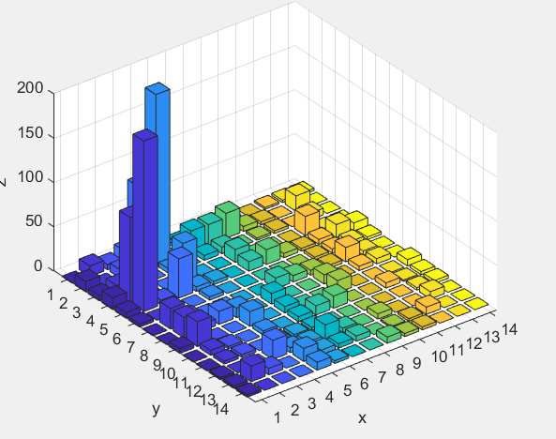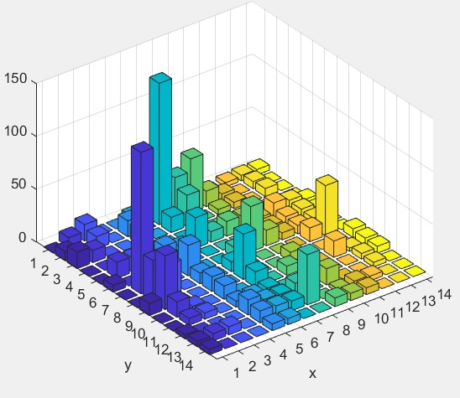

similitude

（Ⅰ） （Ⅱ）

**Figure 1**:Compactness indicator in the first half of the first game

3.2 Compactness Indicator

In football, the core of teamwork is to establish effective connections between players, but this connection is abstract.Therefore, we propose Compactness Indicator to quantify the impact of each pass. At the same time, this indicator is also affected by time and distance.Considering that the passing is directional, there is also a direction for the compactness indicator, from the Origin Player to the Destination Player.

Back to our question, to create a network between players.In order to enable this network to identify network patterns and reflect the team's current strategic tactics,we determine the position of the node by judging the approximate direction of movement through the position and time of two adjacent passes. The strength of the arc of the network based on the distance and time of the passing between the two,The specific diagram is shown in the following figure.We count and calculate specific parameters in the AODC Model to obtain two important compactness indicators.

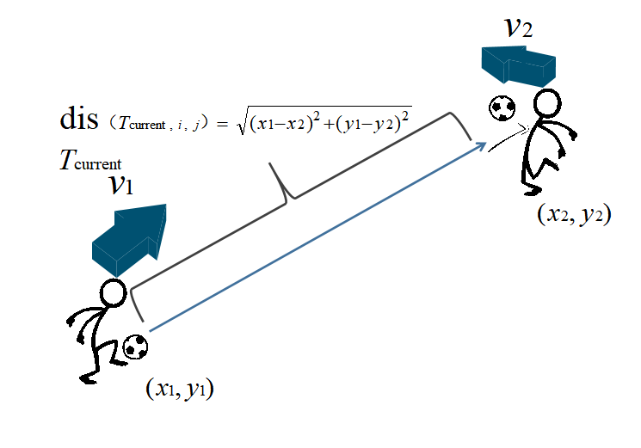

**Figure 2**: Schematic of Compactness Indicators

**3.2.1 Passes Index**

On the court, each pass of a player reflects the close connection between the players. When multiple players cooperate, the ball is transmitted multiple times, and the connection will be closer.But the occasional pass is not equivalent to dyadic and triadic configurations, so we add time to the number of passes factor, and the influence of this pass will become weaker and weaker over time.

 (0<<1)

In a football game, there will be multiple cooperation methods and multiple passes, so we need to add up these passing times factors that decay over time to get the number of passing indicators:



**3.2.2 Pass Distance Index**

In order to simplify the problem, the passing distance should be as short as possible when cooperating between multiple players. In the actual game, short pass is also the main way of passing.So we can think that the shorter the passing distance, the better the Compactness between the two.Since the number of passes has been brought into the concept of time, it can be ignored here.**The Passing Distance Factor** can be calculated using the following formula:



For the passing distance indicator, the effect of each passing distance factor needs to be recorded to obtain the passing distance indicator:



**Figure 3**: Match 6 Comparison of the Compactness Indicator of D2 to D6

In order to further show the impact of these two indicators, we randomly extracted the Compactness Indicator between the two players in the march 6.It can be seen from the figure that both the Passes Index and the Pass Distance Index have a step when a pass occurs.But as time progresses, the Passes Index will decay, and the Pass Distance Index will follow Add up one by one.These two indicators show the effects of two different factors, but they are both related to the Compactness Indicator.Therefore, in the following model optimization, the relationship between the two indicators and the Compactness Indicator will be derived.

3.3 Model of Player Ability

In the Compactness Indicator, due to the limited data, we only consider the influence of teammates.However, due to the different opponents, the compactness between the two people is still different, so we need to consider **the Passing Ability** of different players:



Considering that a good player may get more passing opportunities and more passing failures, some people with fewer passes may have higher Passing Ability. Therefore, we define **the Passing Opportunity Share** here. People with less passing opportunity share are not taken into consideration.



The **Figure 4** is a statistical chart of players' Passing Ability and Passing Opportunity Share.

**Figure 4**: Statistics of Passing Ability

As can be seen from the above figure, some players play a more important role in the game, but their abilities are not satisfactory.Therefore, the Huskies may consider reducing the number of passes for these players and reducing their position in the team strategy.

3.4 Model Optimization

the Passes Index is negatively related to time, and the Pass Distance Index is negatively related to distance.In order to judge the network model and other team cooperation strategies of members in the dynamic close relationship network based on the compactness between two players, we propose the compactness in the Compactness Model Based on Passing (P-CM). We believe that the cooperation in football is mainly composed of fast, short-range conductive balls. Therefore, we propose **the Real-time Relational compactness Function**:



The data in the formula has been processed. After each pass, the growth range of the two parameters is [1, e]. There is no difference in strength between the two indexes. The Real-time Relational compactness Function can be regarded as a weightless function deal with.

In the actual game, the two players have a close relationship at a certain moment. It can only be considered that at the current moment, the playing field requires the cooperation of two players.However, the coach's strategic tactics will make some players more frequent contact, which is reflected in the close relationship between the two in the entire game.We hope to identify network patterns and discover more network attributes in this way. So we propose **the Compactness Formula**:



By accumulating the effect of the compactness of the relationship at each moment, we can understand the compactness between the two players throughout the game.

However, in actual games, some teams hope to obtain a lot of Offensive opportunities through the passing ball. This will make the value of the Compactness Formula high in the whole team, and the corresponding team mode cannot be judged by the threshold. We modify the compactness formula to:



This improves the Adaptability of the compactness formula. We put the value of compactness between players in a 14 * 14 matrix, and get closer players by setting thresholds.Then determine whether it is dyadic or triadic configurations and team formations by the compactness of direction.As shown in the **Figure 5** below, assuming that the four compactness in the figure all meet the threshold, you can determine that players 1, 2, and 3 are triadic configurations and players 1, 4 are dyadic configurations.

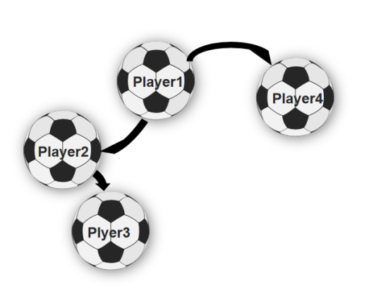

**Figure 5**: Network mode diagram

3.5 Dynamic Compactness Network

Considering the directional nature of the pass, this network is a typical directional network. At the same time, considering the real-time changes in the playing field, we take dynamic information into consideration and establish a complete Dynamic Compactness Network.In this network, the arc represents the relationship between the two. A cell array is used to store the compactness of the passing between the players. The nodes represent the current position of the players. These two sets reflect the course movement in real time as the time changes.

**3.5.1 Establishment of Dynamic Compactness Network**

In the data given, there is no real-time dynamic position of the players. We assume that the player moves in a straight line between two adjacent intervals, and calculates the player's movement speed and direction from the time difference and distance difference between the two times. In this way, we can judge the current formation on the pitch and analyze the real-time motion trajectories of both sides on the pitch. At the same time, we show the compactness of passing between players on the field in real time, so that we can capture the current network model among players, the team's structural, and so on.

In order to be able to visually display the dynamic model, we take a network diagram at a certain moment in the second half of march 1. As **Figure 6,7** .

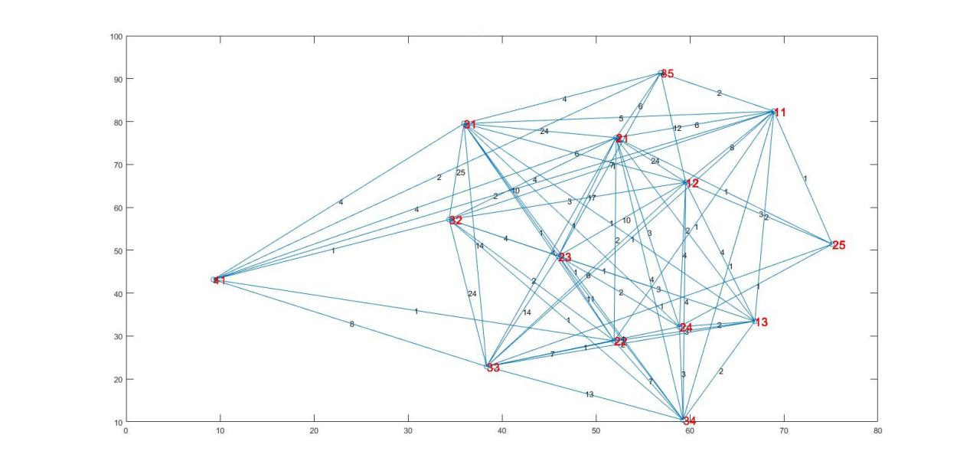

**Figure 6**: Dynamic Compactness Network of the Huskies

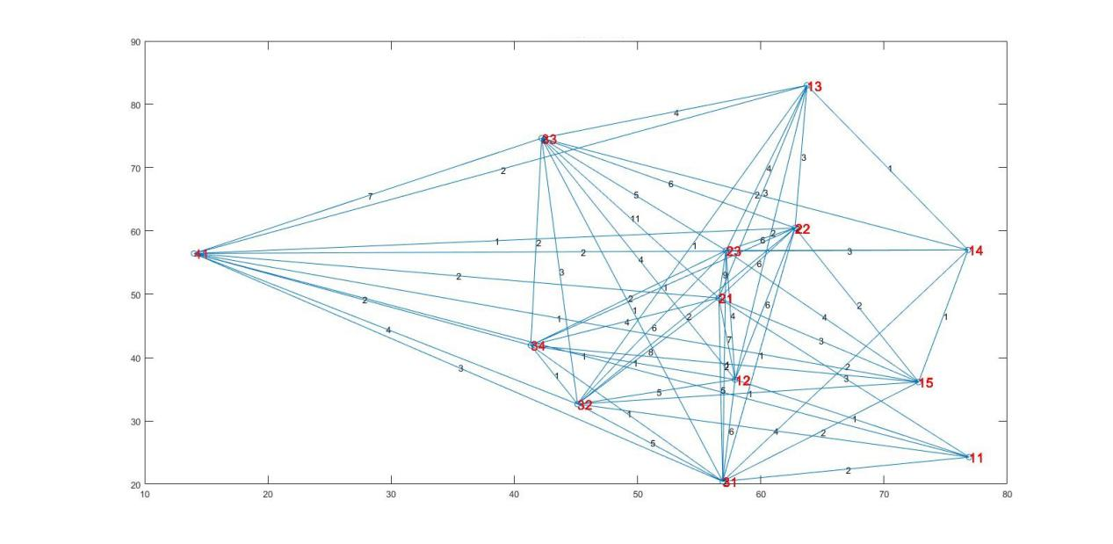

**Figure 7**: Dynamic Compactness Network of the opponent 1

The players are replaced and the tightness between them remains. For the sake of programming, we still think they are on the field, but the position is no longer changed, so the situation in the picture above exceeds 11 players.

**3.5.2 Network Pattern Recognition**

In the picture above, the Dynamic Compactness Network is still complex, and we have further processed the relationship network. First of all, we removed the irrelevant players on the field according to the situation of on-court replacement, and then set a threshold value to highlight the players with higher passing compactness. The two Dynamic Compactness Network shown in the **Figure 8,9** are obtained.

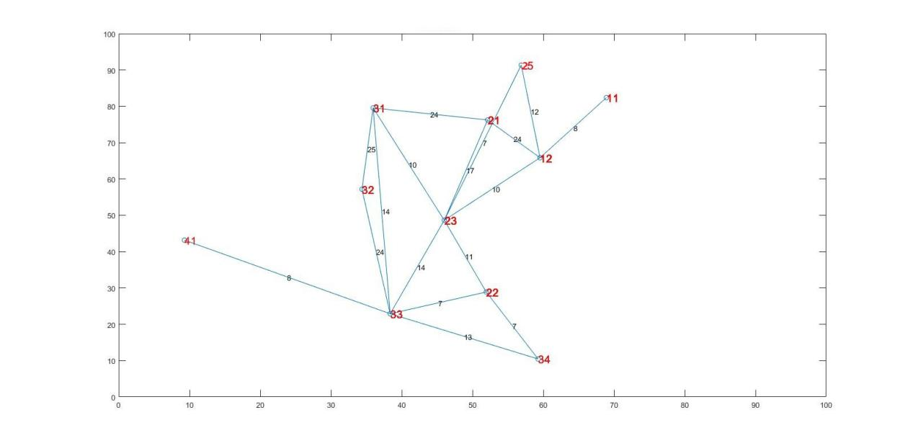

**Figure 8**: Dynamic Compactness Network of the Huskies

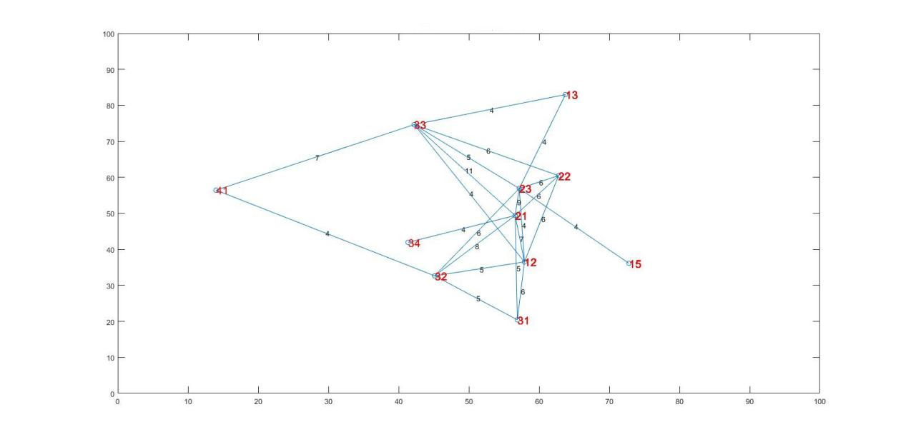

**Figure 9**: Dynamic Compactness Network of the opponent 1

According to the above figure, we can infer the network pattern by the direction and weight of the arc. We use these two networks as examples to explain the identification of network patterns in detail. Comparing the situation we have obtained throughout the season, the two pictures above are typical of the Eskimo game. At the beginning, the Eskimos chose the 4-3-3 lineup. However, when the Eskimos gained an advantage, the coach chose the 4-4-2 lineup to improve the overall defense of the team. This situation has become the main tone of the Eskimo team this season, but the blind pursuit of defense will be counterproductive.

As can be seen from the figure, Huskies takes Huskies_M3 player as the core, and football transfer is mainly done by him. In addition, Huskies_D1, Huskies_M1, and Huskies_F2 form triadic configurations when the attack is launched, and the offense is quickly launched from the side. After that, it is passed back to the player who has been swept from the middle to complete the goal. Because Huskies has a longer defender line, it advances from the backcourt organization when attacking. Triadic configurations and team formations composed of Huskies_D1, Huskies_D2, and Huskies_D3 promote the attack from the backcourt organization. But in the player ability model, Huskies_D3's Passing Ability is questioned. Therefore, we can think that Huskies_D3 is of low value in the process of controlling the ball, and it should appropriately reduce his importance in the team structure at this time.

3.6Model Evaluation And Sensitivity Analysis

In order to test the sensitivity of the model, we need to consider the subjective effects of certain coefficients in the P-C Model. In this model, the two main subjective coefficients are  and .In the actual model, their values are shown in the **Table 2**.

**Table 2:** values of main subjective coefficients

|  |  |
| --- | --- |
| **Subjective coefficient** | **Input Data** |
|  | 5400 |
|  | 141 |

In order to ensure that the variables are unique, we randomly extract the Passes Index and the Pass Distance Index between the two members, and then change the value of the coefficient and visualize the result.

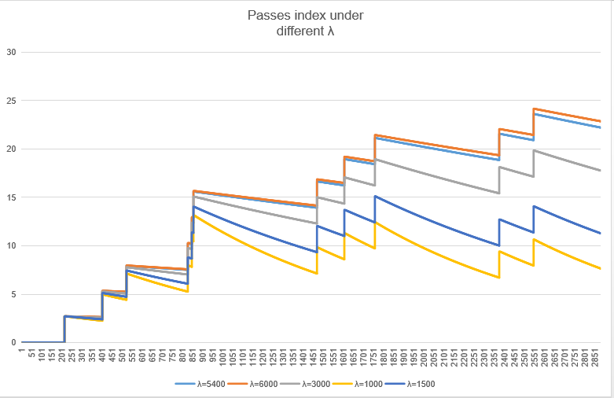

**Figure 10**: Passes Index under different k

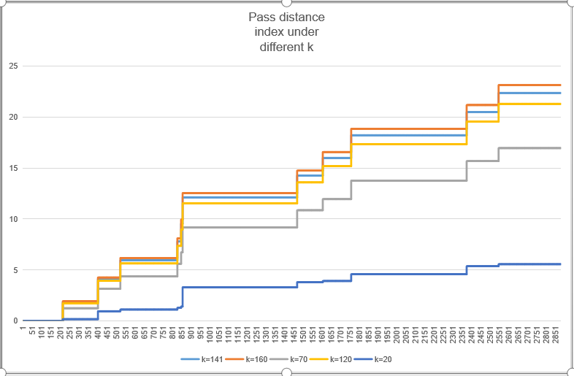

**Figure 11**: Pass Distance Index under different λ

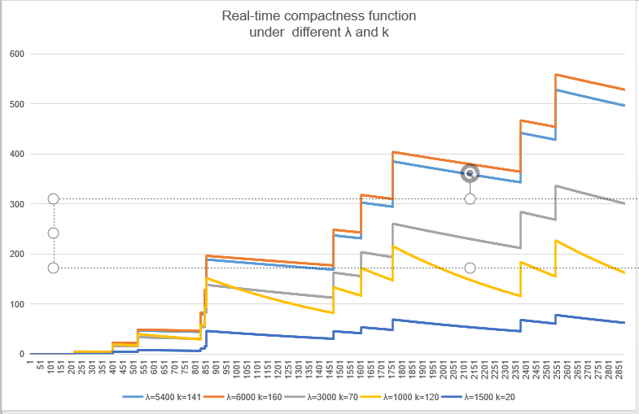

**Figure 12**: Real-time Compactness Function under different λ and k

From **Figure 10** and **Figure 11**, it can be seen that the influence of  on Passes index and  on Pass distance index have both the same points and different points.  and Passes index are negatively correlated, but the degree of negative correlation gradually decreases with the increase of . When a is greater than 141, the increase has almost no effect on the Passes index. In addition, with the increase of , the Passes Index's decay over time characteristics are no longer as obvious as before. but due to the continuous superimposition of the number of pass factors, the attenuation of this decay characteristic has basically disappeared. The relationship between  and Pass distance index is basically the same as the previous two. When  is greater than 5400, increasing a has almost no effect on the Passes index. Since the Pass Distance Index does not decay over time,  has no effect on the Pass Distance Index at this point.

In **Figure 12**, the real-time compactness function is positively related to the sizes of  and , but the positive correlation disappears when a exceeds 5400 and  exceeds 141. And as the ratio of  and  increases, the attenuation characteristics of the real-time compactness function over time become more obvious; as the increasing trend of the ratio of  and  decreases, the real-time compactness function becomes more stable with time.

In the actual close relationship, we believe that the Passes Index and Pass Distance Index have basically the same impact on the passing relationship between teammates. At the same time, we hope that the change of the Real-time Compactness Function is sufficiently obvious, so we can consider the current value to be appropriate.

4 **AODC Model**

We have established a model to evaluate the quality of a team's teamwork from different aspects, called The AODC Model. The AODC model specifically defines four types of performance indicators that reflect teamwork: Adaptability, Offensive, Defensive, and Coordination. We have chosen a limited number of representative factors in accordance with **Pareto's Law** from many factors, and do not measure these indicators after normalization. By judging these indicators to reflect the structure, configuration and dynamic aspects of a team, at the same time, the impact of the team's response to changes in the enemy's strategy can be judged according to the Adaptability. The main strategic intentions of the two teams are to judge the relationship between strategy and counter-strategy.

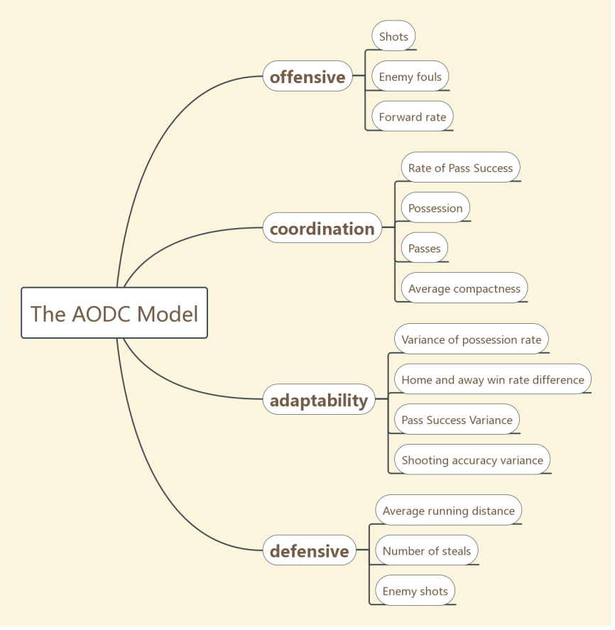

**Figure 13**: The Relationship Between The Four Indicators and Factors.

**Table 3**: Notation

|  |  |  |  |
| --- | --- | --- | --- |
| **Symbol** | **Description** | **Symbol** | **Description** |
|  | Variance of Possession Rate |  | Number of enemy fouls |
|  | Pass Success Variance |  | Number of enemy goals |
|  | Shooting Accuracy Variance |  | Number of others on the ball |
|  | Home win rate |  | Possession |
|  | Away win rate |  | Rate of Pass Success |
|  | Number of Our team's goals |  | The scores of Adaptability |
|  | Number of passes by our team |  | The scores of Offensive |
|  | Number of duels by our team |  | The scores of Defensive |

4.1 **Coordination**

Coordination is an indicator of the compactness of the links between team members in teamwork. We extracted 4 factors from the game data to measure this indicator.

• **Rate of Pass Success:** Passing can improve the compactness between players and strengthen the connection between the two,while the success rate reflects the ability to cooperate

.• **Possession**:Possession is the ratio of the time that the team controls the ball to the total time of the game. It can well reflect the scale of a team using the ball to contact. Greater Possession means better collaborative communication and greater control of the game.

• **Passes**:it is the number of all passes made by a team during a match. More passes means that the more complex the passing network between players, the more connections there will be between players. This parameter can largely reflect the communication within the team.

• **Average Compactness**:Average Compactness is a special parameter generated by our definition-the average value of compactness is taken into consideration, taking into account the length of the pass, the number of passes, the distance passed, and the number of passes corresponding to the number of passes between two players Factors such as the number of ball passes by players have a non-negligible impact on the Coordination indicator.

 represent weights.The mathematical expression for the effect of four data on indicators in Coordination has a form of



4.2 **Adaptability**

Adaptability refers to the team's ability to adapt to a variety of different situations, which reflects the stability of the team when the team is in different situations or facing different opponents. Teams that can play stably can get high evaluation in this indicator. There are four main factors to reflect this indicator.

• **Variance of Possession Rate**: it is the variance of the possession rate in multiple games. It reflects the fluctuation of the team's ability to compete for stadium resources as the opponent changes. We hope that this fluctuation will be small in order to play stably.

•**Home and Away Win Rate Difference**: According to the difference between home and away win rates, we take this difference into the model to reflect the impact of the objective conditions of home and away on the team.

• **Pass Success Variance**: it reflects the fluctuation of the pass success rate in multiple games, which reflects the stability of the team's cooperation status.

• **Shooting Accuracy Variance**:it reflects the stability of the team's Offensive ability.

 represent weights.The mathematical expression for the effect of four data on indicators in Coordination has a form of



4.3 **Offensive**

The performance indicator Offensive reflects the overall pressure of a team in the game and the ability to launch an offense. We use three main factors to reflect this indicator.

• **Shots**: it is the sum of all shots in a game, with or without goals. The number of shots per round is the most intuitive data that reflects the threat of a team. In a football game, an increase in the number of shots per round often leads to an increase in scores, which leads to victory.

•**Enemy Fouls**:Enemy foulsare the number of fouls caused by an enemy team in a game. To some extent, it can reflect the opponent's response to the pressure generated by his team.• Shooting accuracy variance: it reflects the stability of the team's Offensive ability.

•**Forward Rate**:it is the percentage of forward games in a game. The larger this value, the more enthusiastic the team is in attacking, and the longer the opponent is forced to be in Defensive position.

 represent weights.The mathematical expression for the effect of four data on indicators in Coordination has a form of



4.4 **Defensive**

The performance indicator Defensive reflects the team's ability to defend against enemy attacks. We define it with three main factors.

•**Average Running Distance**: it is the average of the total running distance of all the players on the court during the game. The larger the total distance, the more active the player is, and the wider the area that the player can interfere with.

•**Number of Steals**:itis a classic data in football data analysis, which can intuitively reflect the strength of team defense.

•**Enemy Shots**:itcan be used to evaluate the overall effectiveness of the team's defense. The smaller the number of shots, the better the defense.

 represent weights.The mathematical expression for the effect of four data on indicators in Coordination has a form of



4.5 **Normalized Calculation of Factors**

The factors of each performance indicator in The AODC model can clearly reflect the characteristics of each performance indicator. However, the dimensions of each different factor are different, and the data are quite different. Therefore, the model normalizes all data for each different factor to the characteristics of the respective data in order to integrate the various factors.

The factors of Adaptability: The variance of the passing success rate and the possession rate variance are reflected in the discreteness of all matches; the changes in the home and away win rate data reflect the impact of objective events. Here we are more concerned about the difference in win rate. The fluctuation of the variance is more severe; the calculation formulas (), (), (), and () are defined by the characteristics of each data.

** **

** **

The factors of Offensiveness: the two data of the number of shots and fouls per game are intuitive; pushing this data forward is the result of a contest between the two sides, we are more concerned about the part that exceeds the average; Features define calculation formulas ,respectively.



The factors of Defensive: The evaluation of the average overall run refers to the full-field run, which can give a staged score conversion standard; The other three figures intuitively reflect the team's defensive capabilities. The calculation formulas are defined by the characteristics of each data.

** **

the factors of Coordination: the ball control rate reflects the game process between the two sides, we pay more attention to the gap with the median; the number of passes passes a given metric, and the linear value method can be used; compactness data requires periodic evaluation. The calculation formulas are defined by the characteristics of each data.



The normalized results of each factor of the Huskies team are calculated from the above calculation formulas and listed in **Table 4:**

**Table 4**: Normalized Result

|  |  |
| --- | --- |
| **Influencing factors** | **Normalized Result** |
| Variance of Possession Rate  Home and Away Win Rate Difference  Pass Success Variance  Shooting Accuracy Variance | 0.6  0.398  0.81  0.6 |
| Shots  Enemy Fouls  Forward Rate | 0.74  0.629  0.64 |
| Average Running Distance  Number of Steals  Enemy Shots | 0.76  0.668  0.619 |
| Possession  Rate of Pass Success  Passes  Average Compactness | 0.5364  0.8414  0.56  0.6 |

4.6 **Weight Calculation**

We construct a judgment matrix for the influencing factors of each performance indicator, and use the analytic hierarchy process to calculate the weight value of each factor on the performance indicator to which it belongs. The calculated weight values are listed in the **Table 5.**

**Table 5**: Weight

|  |  |
| --- | --- |
| **Influencing factors** | **Weights** |
| Variance of Possession Rate  Home and Away Win Rate Difference  Pass Success Variance  Shooting Accuracy Variance | 0.2863  0.4348  0.0969  0.182 |
| Shots  Enemy Fouls  Forward Rate | 0.5714  0.1429  0.2857 |
| Average Running Distance  Number of Steals  Enemy Shots | 0.5  0.25  0.25 |

Then we have the following complete calculation formula:

**   **

Substituting the normalized score data into the above formula, the average score obtained is a number between zero and one. A higher score indicates that the team is stronger in this regard. The average score of each performance indicator of the Huskies' 38 games is shown in the **Figure 14**.

**Figure 14**: The relationship between the four indicators and factors.

As can be seen from the figure, the Huskies team is a team with both offense and defense, but because of overemphasizing this point, the Huskies is not so prominent in both aspects. In terms of Coordination, the Huskies is also obviously very mediocre, with fewer passing balls and mostly relying on opponents' mistakes to score.

4.7 **Simulation**

We select data from the authoritative football website, use this model to analyze, give the standard value of the team cooperation index we set, and compare it with the team cooperation attribute of the analyzed team. The parameters shown reflect the teamwork attributes of the team to some extent. We have selected Norwich Club, Bayern Munich Club, Juventus in 29 games in 2019 [5] for analysis. The analysis results are shown in Table 6 and Table 7:

**Table 6**: Weights

|  |  |  |  |  |  |
| --- | --- | --- | --- | --- | --- |
| **Influencing factors** | **Norwich** | **Bayern Munich** | | **Juventus** | |
| Variance of Possession Rate  Home and Away Win Rate Difference  Pass Success Variance  Shooting Accuracy Variance | 0.65  0.71  0.65  0.67 | | 0.2863  0.4348  0.0969  0.182 | | 0.74  0.95  0.85  0.80 |
| Shots  Enemy Fouls  Forward Rate | 0.79  0.72  0.69 | | 0.5714  0.1429  0.2857 | | 0.85  0.73  0.70 |
| Average Running Distance  Number of Steals  Enemy Shots | 0.65  0.71  0.632 | | 0.5  0.25  0.25 | | 0.73  0.85  0.871 |
| Possession  Rate of Pass Success  Passes  Average Compactness | 0.712  0.71  0.61  0.652 | | 0.2863  0.4348  0.0969  0.182 | | 0.742  0.874  0.81  0.801 |

**Table 7**: Performance indicator average score for four clubs

|  |  |  |  |  |
| --- | --- | --- | --- | --- |
|  | **Adaptability** | **Coordination** | **Offensive** | **Defensive** |
| **Bayern Munich** | 0.8835298 | 0.825613 | 0.858563 | 0.69925 |
| **Juventus** | 0.82 | 0.830 | 0.790 | 0.853 |
| **Norwich** | 0.66 | 0.68 | 0.75 | 0.66 |
| **Huskies** | 0.533 | 0.695 | 0.701 | 0.65 |

Compared with the other three teams, the Huskies is a team with a lower middle score, and its four performance indicators are significantly weaker than other teams.At the same time, the attributes represented by these four performance indicators are very close to the style of the other three teams.The Bayern Munich focuses on offense and coordination, and the defense is weak, while the Juventus is more comprehensive offensive and defensive, unlike the previous two Norwich's record is closer to the Huskies, so we can consider these four performance indicators to be more accurate.

The Huskies team has been analyzed before, and here we will focus on evaluating his low Adaptability. The low Adaptability shows that the Huskies team has no way to restrain the change of opponent's strategy and strategy, and the coach's tactics lack flexibility. At the same time, when the Huskies is more defensive at certain moments, that is, when the Husky team's formation is more mainly for defense, teams with higher Coordination can often limit the Huskies team well. We therefore propose that effectiveness of the strategy is related to the anti-strategy to a certain extent.

**5 Build An Effective Team**

Competitive team sports is a typical teamwork activity. In the two models that have been established the P-C Model and the AODC Model, we explore the internal connection of football team cooperation and how it affects the performance of team cooperation, and gives the a way to evaluate teamwork. Based on these two models, we can build a judgment basis for an effective team

Based on the P-C Model and the AODC Model, we consider the four levels of the team structure: the individual level, the level between members, the level of the overall members, and the level of the team. And at these six levels, the six indicators shown in **Figure 15** below are proposed.

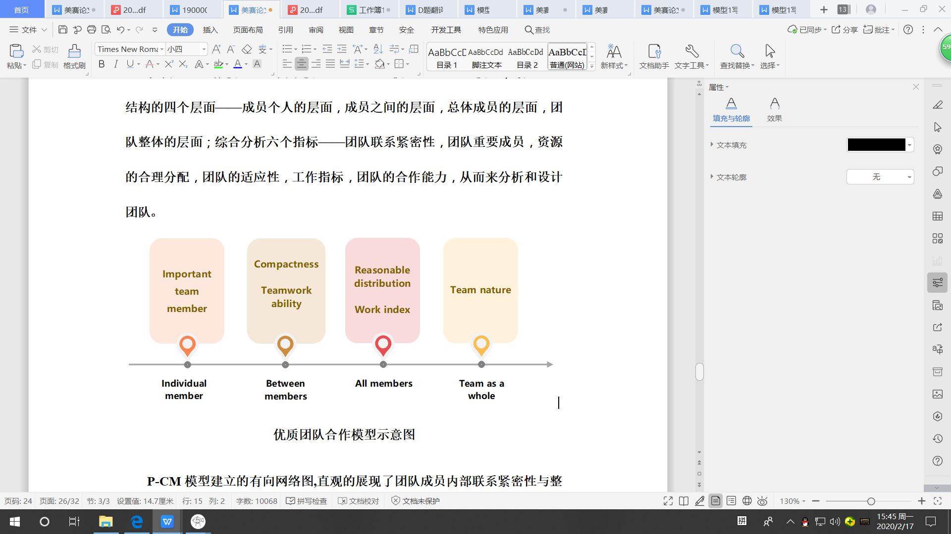

**Figure 15**: Schematic diagram of a good teamwork model

The directed network diagram established by the P-C Model intuitively shows the compactness and integration of internal connections among team members.the P-C Model is applied to a wide range of teamwork in society. Compactness is the efficiency of resource transfer and integration within the team. It affects the effectiveness of teamwork at the level of members.Through the relationship network in the P-C Model, we can know the members who are important in cooperation, and evaluate whether these members are valuable for teamwork by evaluating the value of these members.The directed network embodied in the P-C Model can be equivalent to the flow of resources and information within the team.Through the analysis of these data, we can draw the impact of the reasonable allocation of resources on teamwork, which affects the effectiveness of teamwork at the level of all members.

In the above, the AODC model intuitively reflects the nature of the team through the basic data.Therefore, we can use the data provided by other models to capture the transmission and communication of team resources and information, important member information, the team's recent performance, member work indicators and other information to quantify six indicators of high-quality team cooperation models.

**6 Strengths And Weaknesses**

**6.1** **Strengths**

•The factors considered in the AODC model are relatively comprehensive, and the model is not prone to misjudgment due to lack of consideration.

•The Compactness Formula reflects the influence of time and distance on the relationship between the two. At the same time, using the integral method can reflect the main closeness relationship in the game, so as to judge the team's strategic tactics.

•Our Dynamic Compactness Network can display the distribution of players on the court and their connections in real time, which can well judge the current situation of the stadium.

•We introduce a player capability model, which is helpful for judging an individual's overall value. The coach can adjust the tactical status of players with low value based on this model and the dynamic close relationship network.

**6.2** **Weaknesses**

•The two main models have a large demand for data and a large amount of data processing, so they are not suitable for situations where the amount of data is small.

•Due to the amount of data, our compactness function uses fewer indicators. In the actual stadium, more indicators should be used to complete the analysis.

**7** **Conclusion：A Letter Of Advice to The Management of The Huskies**

Dear Sir/Madam,my company, Intrepid Champion Modeling (ICM), is invited to lend a helping hand to you to understand the team's dynamics, explore the complex interactions within the team, and seek for cooperative strategies that enhance the overall strength of the team.  
 First and foremost, we reckon that your team's overall Compactness is poor, and the team's strategic tactics are relatively conservative compared to other teams, so we recommend that your team ought to be more determined to implement some tactics and open the opponent's defense by transmitting the ball .

Secondly, the overall strength of the Huskies is average,which is the result of the coach's emphasis on Offensive and Defensive balance, but the blind pursuit of defense after the Offensive lead will not have much positive impact on the team. We reckon that the coach are supposed to be aware of the situation on the court and understand the timing of attack or defense so as to strike a balance between offense and defense.

Apart from this, we found some low-value players through the network model we built.Given that the team has the ability, you might as well consider buying some backcourt players who are stable in ball control, excellent at assists and conduction. Coaches can also adjust strategies and tactics for these lower value members.

What’s more,we think that the Huskies' Adaptability is poor, on account that the team members are unstable, affected by away games, and the coach's ability to respond to opponents' strategy changes is not strong.

Last but not least, We wrote an extremely complicated program to get the offensive heat map of the Huskies team this season. The yellow area represents the average offensive area of our players throughout the season. Since this area is close to the boundary, we may safely draw a conclusion that their main offensive method is the wing attack, pulling the opponent's defense line by the length of the court, which is consistent with the results of the P-C model analysis.And the positions of the players are scattered during the offense, which indicates that the coach is afraid of attacking when deploying tactics and is worried about the opponent's defensive attack. But in fact this strategy has greatly reduced the overall competitiveness of the Huskies.

Sincere appreciation for taking the time to read our manuscript. I hope our suggestions will be helpful to you. I’m looking forward to your success in the new season!

Sincerely

members of team#2010905

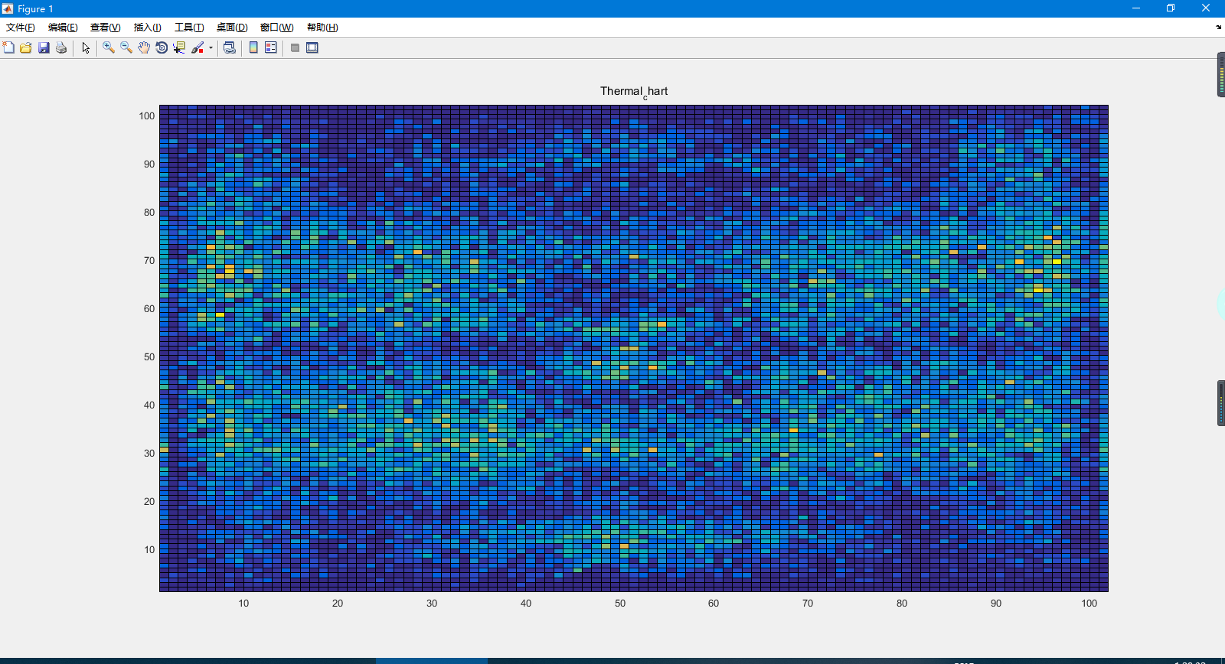

**Figure 16**: Offensive heat map throughout the season

**References**

[1] Mike Hughes & Ian Franks (2005) Analysis of passing sequences, shots and goals in soccer, Journal of Sports Sciences, 23:5, 509-514, DOI: 10.1080/02640410410001716779

[2] Duch J., Waitzman J.S., Amaral L.A.N. (2010). Quantifying the performance of individual

players in a team activity. PLoS ONE, 5: e10937.

[3]Buldú, J.M., Busquets, J., Echegoyen, I. et al. (2019). Defining a historic football team: Using Network Science to analyze Guardiola’s F.C. Barcelona. Sci Rep, 9, 13602.

[4] Thomas U. Grund,Network structure and team performance: The case of English Premier League soccer teams,Social Networks,Volume 34, Issue 4, October 2012, Pages 682-690

[5] https://www.whoscored.com/Teams/37/Fixtures/Germany-Bayern-Munich

**Appendices matlab code**

1. clc,clear;
2. %Macro definition
3. position_x = 1;                 %col 1 x coordinate  array
4. position_y = 2;                 %col 2 y coordinate  array
5. v_x = 3;                        %col 3 x Coordinate change array
6. v_y = 4;                        %col 4 y Coordinate change array?
7. name = 5;                       %col 5 Grade
8. e_time = 6;                     %col 6 Event update time
9. player_event_num = 7;           %col 7 Event sum
10. player_event_count = 8;         %col 8 Record variables
11. player_game_state = 9;          %col 9 state of athletes
12. player_time = 10;               %State change time
13. xiachang  = 11;
14. %% Init data
15. [number,txt,raw] = xlsread('C:/Users/Administrator/Desktop/bisai/2020_Problem_D_DATA/passingevents.csv');
16. [number_1,txt_1,raw_1] = xlsread('C:/Users/Administrator/Desktop/bisai/2020_Problem_D_DATA/fullevents.csv');
17. [hang,lie] = size(txt);
18. [hang_1,lie_1] = size(txt_1);
19. field_num = 1:1:38;
20. Huskies_pass_num = zeros(1,38);                     %Huskies Pass number matrix
21. Opponent_pass_num = zeros(1,38);                    %Opponent Pass number matrix
22. Huskies_team_state = cell(40,30);                   %Huskies team state matrix row game_number col team_name
23. Opponent_team_state = cell(40,30);                  %Opponent team state matrix row game_number col team_name
24. Huskies_team_num = zeros(1,38);                     %Huskies team number matrix col game_number
25. Opponent_team_num = zeros(1,38);                    %Opponent team number matrix col game_number
26. Huskies_count_one = 0;                              %Huskies OriginPlayerID Record variables
27. Huskies_count_two = 0;                              %Huskies DestinationPlayerID Record variables
28. Opponent_count_one = 0;                             %Opponent OriginPlayerID Record variables
29. Opponent_count_two = 0;                             %Opponent DestinationPlayerID Record variables
30. Match_1H_count = zeros(1,38);                       %First half of game time col game_number
31. Match_2H_count = zeros(1,38);                       %Second half of game time col game_number
32. unit_1H_time = zeros(1,38);                         %First half of game Unit conversion col game_number
33. unit_2H_time = zeros(1,38);                         %Second half of game Unit conversion col game_number
34. %% Find out how many teams record their names **and** their names
35. [team_storage,team_num] = species_count(2,2,hang,txt);
36. %% Query event home directory type
37. [event_type,event_type_num] = species_count(7,2,hang_1,txt_1);
38. %% Query event subdirectory type
39. [sub_event_type,sub_type_num] = sub_species_count(7,event_type_num,8,2,hang_1,txt_1,event_type);
40. %% Record the number of passes per game
41. sum_pass_num = numder_species_sum(1 , 1 , (hang-1) , number , field_num , 38);
42. %% Number of recorded events
43. sum_event = numder_species_sum(1 , 1 , (hang_1-1) , number_1 , field_num , 38);
44. %% Count the total passes of Huskies **and** opponent
45. j = 1;
46. **for** i = 1:38
47. Huskies_pass_num(1,i) = species_sum(2,j+1,j+sum_pass_num(1,i),txt,team_storage{1,1});
48. Opponent_pass_num(1,i) = sum_pass_num(1,i) - Huskies_pass_num(1,i);
49. j = j + sum_pass_num(1,i);
50. end
51. %% Record the time of changing field
52. j = 0;
53. **for** i = 1:38
54. Match_1H_count(1,i) = species_sum(5,j+1,j+sum_event(1,i),txt_1,'1H');
55. Match_2H_count(1,i) = sum_event(1,i);
56. unit_1H_time(1,i) = number_1(Match_1H_count(1,i)+j,6)/3600;   %Conversion to seconds
57. unit_2H_time(1,i) = number_1(Match_2H_count(1,i)+j,6)/3600;
58. j = j + sum_event(1,i);
59. end
60. %% Count player name information
61. j = 1;
62. **for** i = 1:38
63. [Huskies_team_state(i,:),Huskies_team_num(1,i),Opponent_team_state(i,:),Opponent_team_num(1,i)] = ...
64. player_species_count(3,j+1,j+sum_event(1,i),txt_1,team_storage{1,1});
65. j = j + sum_event(1,i);
66. end
67. %% Member information cell initialization
68. Huskies_pixel_info = cell(1,38);
69. Opponent_pixel_info = cell(1,38);
70. **for** count = 1:38
71. Huskies_pixel_info{1,count} = cell(Huskies_team_num(1,count),10);
72. Opponent_pixel_info{1,count} = cell(Huskies_team_num(1,count),10);
73. end
75. **for** count = 1:38
76. **for** i = 1:Huskies_team_num(1,count)
77. Huskies_pixel_info{1,count}{i,player_game_state} = 0;
78. end
79. end
80. %% Event recorder initialization
81. **for** count = 1:38
82. **for** i = 1:Huskies_team_num(1,count)
83. Huskies_pixel_info{1,count}{i,8} = 1;
84. Huskies_pixel_info{1,count}{i,9} = 0;
85. end
86. **for** i = 1:Opponent_team_num(1,count)
87. Opponent_pixel_info{1,count}{i,8} = 1;
88. Opponent_pixel_info{1,count}{i,9} = 0;
89. end
90. end
91. %% Label team members
92. **for** count = 1:38
93. **for** i = 1:Huskies_team_num(1,count)
94. Huskies_pixel_info{1,count}{i,name} = player_str_to_number(Huskies_team_state{count,i});
95. end
96. **for** i = 1:Opponent_team_num(1,count)
97. Opponent_pixel_info{1,count}{i,name} = player_str_to_number(Opponent_team_state{count,i});
98. end
99. end
100. %% Bubble sort
101. **for** count = 1:38
102. **for** i = 2 : Huskies_team_num(1,count)-1
103. **for** j = Huskies_team_num(1,count) : -1 : i
104. **if** Huskies_pixel_info{1,count}{j,name} <  Huskies_pixel_info{1,count}{j-1,name}
105. num = Huskies_pixel_info{1,count}{j,name};
106. Huskies_pixel_info{1,count}{j,name} = Huskies_pixel_info{1,count}{j-1,name};
107. Huskies_pixel_info{1,count}{j-1,name} = num;
108. end
109. end
110. end
112. **for** i = 2 : Opponent_team_num(1,count)-1
113. **for** j = Opponent_team_num(1,count) : -1 : i
114. **if** Opponent_pixel_info{1,count}{j,name} <  Opponent_pixel_info{1,count}{j-1,name}
115. num = Opponent_pixel_info{1,count}{j,name};
116. Opponent_pixel_info{1,count}{j,name} = Opponent_pixel_info{1,count}{j-1,name};
117. Opponent_pixel_info{1,count}{j-1,name} = num;
118. end
119. end
120. end
121. end
122. %% Record team coordinate information
123. j=1;
124. char_value = 0;
125. i = 0;
126. flag = 0;
127. **for** count = 1:38
128. **for** num = 1:sum_event(1,count)
129. **if** ~strcmp(txt_1{num+j,7},'Substitution')
130. char_value = player_str_to_number(txt_1{num+j,3});
131. [i , flag] = search_player(txt_1{num+j,3},char_value,Huskies_pixel_info{1,count},Huskies_team_num(1,count),Opponent_pixel_info{1,count},Opponent_team_num(1,count));
132. **if** flag == 2
133. Huskies_pixel_info{1,count}{i,position_x} = [Huskies_pixel_info{1,count}{i,position_x},number_1(num-1+j,9)];                    %Huskies Pass player x position
134. Huskies_pixel_info{1,count}{i,position_y} = [Huskies_pixel_info{1,count}{i,position_y},number_1(num-1+j,10)];                   %Huskies Pass player y position
135. Huskies_pixel_info{1,count}{i,e_time} = [Huskies_pixel_info{1,count}{i,e_time},number_1(num-1+j,6)];                            %Huskies Pass time
136. Huskies_pixel_info{1,count}{i,player_time} = [Huskies_pixel_info{1,count}{i,player_time},txt_1{num+j,5}];
137. **if** ((Huskies_pixel_info{1,count}{i,player_game_state} ~= 3)&&(Huskies_pixel_info{1,count}{i,player_game_state} ~= 2))
138. Huskies_pixel_info{1,count}{i,player_game_state} = 1;
139. end
140. **else**
141. Opponent_pixel_info{1,count}{i,position_x} = [Opponent_pixel_info{1,count}{i,position_x},(100-number_1(num-1+j,9))];    %Opponent Pass player x position
142. Opponent_pixel_info{1,count}{i,position_y} = [Opponent_pixel_info{1,count}{i,position_y},(100-number_1(num-1+j,10))];   %Opponent Pass player y position
143. Opponent_pixel_info{1,count}{i,e_time} = [Opponent_pixel_info{1,count}{i,e_time},number_1(num-1+j,6)];                  %Opponent Pass time
144. Opponent_pixel_info{1,count}{i,player_time} = [Opponent_pixel_info{1,count}{i,player_time},txt_1{num+j,5}];
145. **if** ((Opponent_pixel_info{1,count}{i,player_game_state} ~= 3)&&(Opponent_pixel_info{1,count}{i,player_game_state} ~= 2))
146. Opponent_pixel_info{1,count}{i,player_game_state} = 1;
147. end
148. end
149. **if** ~isempty(txt_1{num+j,4})
150. char_value = player_str_to_number(txt_1{num+j,4});
151. [i , flag] = search_player(txt_1{num+j,4},char_value,Huskies_pixel_info{1,count},Huskies_team_num(1,count),Opponent_pixel_info{1,count},Opponent_team_num(1,count));
152. **if** flag == 2
153. Huskies_pixel_info{1,count}{i,position_x} = [Huskies_pixel_info{1,count}{i,position_x},number_1(num-1+j,11)];
154. Huskies_pixel_info{1,count}{i,position_y} = [Huskies_pixel_info{1,count}{i,position_y},number_1(num-1+j,12)];
155. Huskies_pixel_info{1,count}{i,e_time} = [Huskies_pixel_info{1,count}{i,e_time},number_1(num-1+j,6)];
156. Huskies_pixel_info{1,count}{i,player_time} = [Huskies_pixel_info{1,count}{i,player_time},txt_1{num+j,5}];
157. **if** ((Huskies_pixel_info{1,count}{i,player_game_state} ~= 3)&&(Huskies_pixel_info{1,count}{i,player_game_state} ~= 2))
158. Huskies_pixel_info{1,count}{i,player_game_state} = 1;
159. end
160. **else**
161. Opponent_pixel_info{1,count}{i,position_x} = [Opponent_pixel_info{1,count}{i,position_x},(100-number_1(num-1+j,11))];
162. Opponent_pixel_info{1,count}{i,position_y} = [Opponent_pixel_info{1,count}{i,position_y},(100-number_1(num-1+j,12))];
163. Opponent_pixel_info{1,count}{i,e_time} = [Opponent_pixel_info{1,count}{i,e_time},number_1(num-1+j,6)];
164. Opponent_pixel_info{1,count}{i,player_time} = [Opponent_pixel_info{1,count}{i,player_time},txt_1{num+j,5}];
165. **if** ((Opponent_pixel_info{1,count}{i,player_game_state} ~= 3)&&(Opponent_pixel_info{1,count}{i,player_game_state} ~= 2))
166. Opponent_pixel_info{1,count}{i,player_game_state} = 1;
167. end
168. end
169. end
170. **else**
171. char_value = player_str_to_number(txt_1{num+j,3});
172. [i , flag] = search_player(txt_1{num+j,3},char_value,Huskies_pixel_info{1,count},Huskies_team_num(1,count),Opponent_pixel_info{1,count},Opponent_team_num(1,count));
173. **if** flag == 2
174. Huskies_pixel_info{1,count}{i,player_game_state} = 2;                      %substitution
175. Huskies_pixel_info{1,count}{i,e_time} = [Huskies_pixel_info{1,count}{i,e_time},number_1(num-1+j,6)];        %substitution time
176. Huskies_pixel_info{1,count}{i,player_time} = [Huskies_pixel_info{1,count}{i,player_time},txt_1{num+j,5}];
177. **else**
178. Opponent_pixel_info{1,count}{i,player_game_state} = 2;
179. Opponent_pixel_info{1,count}{i,e_time} = [Opponent_pixel_info{1,count}{i,e_time},number_1(num-1+j,6)];
180. Opponent_pixel_info{1,count}{i,player_time} = [Opponent_pixel_info{1,count}{i,player_time},txt_1{num+j,5}];
181. end
182. **if** ~isempty(txt_1{num+j,4})
183. char_value = player_str_to_number(txt_1{num+j,4});
184. [i , flag] = search_player(txt_1{num+j,4},char_value,Huskies_pixel_info{1,count},Huskies_team_num(1,count),Opponent_pixel_info{1,count},Opponent_team_num(1,count));
185. **if** flag == 2
186. Huskies_pixel_info{1,count}{i,player_game_state} = 3;
187. Huskies_pixel_info{1,count}{i,e_time} = [Huskies_pixel_info{1,count}{i,e_time},number_1(num-1+j,6)];
188. Huskies_pixel_info{1,count}{i,player_time} = [Huskies_pixel_info{1,count}{i,player_time},txt_1{num+j,5}];
189. **else**
190. Opponent_pixel_info{1,count}{i,player_game_state} = 3;
191. Opponent_pixel_info{1,count}{i,e_time} = [ Opponent_pixel_info{1,count}{i,e_time},number_1(num-1+j,6)];
192. Opponent_pixel_info{1,count}{i,player_time} = [Opponent_pixel_info{1,count}{i,player_time},txt_1{num+j,5}];
193. end
194. end
195. end
196. end
197. j = j + sum_event(1,count);
198. flag = 1;
199. end
200. %% Information quantity calculation
201. **for** count = 1:38
202. **for** i = 1:Huskies_team_num(1,count)
203. char_value = Huskies_pixel_info{1,count}{i,position_x};
204. [x1,x2] = size(char_value);
205. Huskies_pixel_info{1,count}{i,player_event_num} = x2;
206. end
207. **for** i = 1:Opponent_team_num(1,count)
208. char_value = Opponent_pixel_info{1,count}{i,position_x};
209. [x1,x2] = size(char_value);
210. Opponent_pixel_info{1,count}{i,player_event_num} = x2;
211. end
212. end
213. %% Initialization of player coordinate variable
214. Huskies_map_x = cell(1,38);
215. Huskies_map_y = cell(1,38);
216. Opponent_map_x = cell(1,38);
217. Opponent_map_y = cell(1,38);
218. **for** count = 1:38
219. Huskies_map_x{1,count} = zeros(1,Huskies_team_num(1,count));
220. Huskies_map_y{1,count}=  zeros(1,Huskies_team_num(1,count));
221. Opponent_map_x{1,count} =zeros(1,Opponent_team_num(1,count));
222. Opponent_map_y{1,count} = zeros(1,Opponent_team_num(1,count));
223. end
224. %% Calculation of players' average coordinates
225. **for** count = 1:38
226. **for** i = 1:Huskies_team_num(1,count)
227. **for** j = 1:Huskies_pixel_info{1,count}{i,7}
228. Huskies_map_x{1,count}(1,i) = Huskies_map_x{1,count}(1,i) + Huskies_pixel_info{1,count}{i,position_x}(1,j);
229. Huskies_map_y{1,count}(1,i) = Huskies_map_y{1,count}(1,i) + Huskies_pixel_info{1,count}{i,position_y}(1,j);
230. end
231. Huskies_map_x{1,count}(1,i) = Huskies_map_x{1,count}(1,i)/Huskies_pixel_info{1,count}{i,player_event_num};
232. Huskies_map_y{1,count}(1,i) = Huskies_map_y{1,count}(1,i)/Huskies_pixel_info{1,count}{i,player_event_num};
233. end
234. **for** i = 1:Opponent_team_num(1,count)
235. **for** j = 1:Opponent_pixel_info{1,count}{i,7}
236. Opponent_map_x{1,count}(1,i) = Opponent_map_x{1,count}(1,i) + Opponent_pixel_info{1,count}{i,position_x}(1,j);
237. Opponent_map_y{1,count}(1,i) = Opponent_map_y{1,count}(1,i) + Opponent_pixel_info{1,count}{i,position_y}(1,j);
238. end
239. Opponent_map_x{1,count}(1,i) = Opponent_map_x{1,count}(1,i)/Opponent_pixel_info{1,count}{i,player_event_num};
240. Opponent_map_y{1,count}(1,i) = Opponent_map_y{1,count}(1,i)/Opponent_pixel_info{1,count}{i,player_event_num};
241. end
242. end
243. %% Search the corresponding adjacency matrix information
244. j=1;
245. Huskies_team_graph = cell(1,38); %Huskies Graph theory storage variable of game passing col game_number
246. Opponent_team_graph = cell(1,38); %Opponent Graph theory storage variable of game passing col game_number
247. **for** count = 1:38
248. Huskies_team_graph{1,count} = zeros(Huskies_team_num(1,count),Huskies_team_num(1,count));%Huskies adjacency matrix
249. Opponent_team_graph{1,count} = zeros(Opponent_team_num(1,count),Opponent_team_num(1,count));%Opponent adjacency matrix
250. end
251. **for** count = 1:38
252. **for** num = 1:sum_pass_num(1,count)
253. char_value = player_str_to_number(txt{num+j,3});
254. [i , flag] = search_player(txt{num+j,3},char_value,Huskies_pixel_info{1,count},Huskies_team_num(1,count),Opponent_pixel_info{1,count},Opponent_team_num(1,count));
255. **if** flag == 2
256. Huskies_count_one = i;                             %Record passers
257. **else**
258. Opponent_count_one = i;
259. end
260. char_value = player_str_to_number(txt{num+j,4});
261. [i , flag] = search_player(txt{num+j,4},char_value,Huskies_pixel_info{1,count},Huskies_team_num(1,count),Opponent_pixel_info{1,count},Opponent_team_num(1,count));
262. **if** flag == 2
263. Huskies_count_two = i ;     %Record passers
264. Huskies_team_graph{1,count}(Huskies_count_one,Huskies_count_two) = Huskies_team_graph{1,count}(Huskies_count_one,Huskies_count_two) + 1;
265. Huskies_team_graph{1,count}(Huskies_count_two,Huskies_count_one) = Huskies_team_graph{1,count}(Huskies_count_two,Huskies_count_one) + 1;
266. **else**
267. Opponent_count_two = i;    %Record Opponent Destination Player ID number
268. Opponent_team_graph{1,count}(Opponent_count_one,Opponent_count_two) = Opponent_team_graph{1,count}(Opponent_count_one,Opponent_count_two) + 1;
269. Opponent_team_graph{1,count}(Opponent_count_two,Opponent_count_one) = Opponent_team_graph{1,count}(Opponent_count_two,Opponent_count_one) + 1;
270. end
271. end
272. j = j + sum_pass_num(1,count);
273. end
274. %% Initialization of players' passing compactness
275. Huskies_Close_num = cell(1,38);
276. Opponent_Close_num = cell(1,38);
277. Huskies_graph_z = cell(1,38);
278. Opponent_graph_z = cell(1,38);
279. **for** count = 1:38
280. Huskies_Close_num{1,count} = zeros(Huskies_team_num(1,count),Huskies_team_num(1,count));
281. Opponent_Close_num{1,count} = zeros(Opponent_team_num(1,count),Opponent_team_num(1,count));
282. Huskies_graph_z{1,count} = zeros(Huskies_team_num(1,count),Huskies_team_num(1,count));
283. Opponent_graph_z{1,count}= zeros(Opponent_team_num(1,count),Opponent_team_num(1,count));
284. end
285. %% Search **for** the corresponding **pass** compactness matrix information
286. j = 1;
287. **for** count = 1:38
288. **for** num = 1:sum_pass_num(1,count)
289. char_value = player_str_to_number(txt{num+j,3});
290. [i , flag] = search_player(txt{num+j,3},char_value,Huskies_pixel_info{1,count},Huskies_team_num(1,count),Opponent_pixel_info{1,count},Opponent_team_num(1,count));
291. **if** flag == 2
292. Huskies_count_one = i;                             %Record passers
293. **else**
294. Opponent_count_one = i;                             %Record passers
295. end
296. char_value = player_str_to_number(txt{num+j,4});
297. [i , flag] = search_player(txt{num+j,4},char_value,Huskies_pixel_info{1,count},Huskies_team_num(1,count),Opponent_pixel_info{1,count},Opponent_team_num(1,count));
298. **if** flag == 2
299. Huskies_count_two = i ;
300. **if** num == 1
301. Huskies_Close_num{1,count} = updata(Huskies_team_num(1,count),Huskies_Close_num{1,count},Huskies_count_one ,Huskies_count_two,0,number(num-1+j,6),0.1,10,number(num-1+j,8),number(num-1+j,9),number(num-1+j,10),number(num-1+j,11),120);
302. **else**
303. Huskies_Close_num{1,count} = updata(Huskies_team_num(1,count),Huskies_Close_num{1,count},Huskies_count_one ,Huskies_count_two,number(num-2+j,6),number(num-1+j,6),0.1,10,number(num-1+j,8),number(num-1+j,9),number(num-1+j,10),number(num-1+j,11),120);
304. end
305. Huskies_graph_z{1,count} = Huskies_graph_z{1,count} + Huskies_Close_num{1,count};
306. **else**
307. Opponent_count_two = i;
308. **if** num == 1
309. Opponent_Close_num{1,count} = updata(Opponent_team_num(1,count),Opponent_Close_num{1,count},Opponent_count_one ,Opponent_count_two,0,number(num-1+j,6),0.1,10,number(num-1+j,8),number(num-1+j,9),number(num-1+j,10),number(num-1+j,11),120);
310. **else**
311. Opponent_Close_num{1,count} = updata(Opponent_team_num(1,count),Opponent_Close_num{1,count},Opponent_count_one ,Opponent_count_two,number(num-2+j,6),number(num-1+j,6),0.1,10,number(num-1+j,8),number(num-1+j,9),number(num-1+j,10),number(num-1+j,11),120);
312. end
313. Opponent_graph_z{1,count} = Opponent_graph_z{1,count} + Opponent_Close_num{1,count};
314. end
315. end
316. j = j + sum_pass_num(1,count);
317. end
318. %% Ball control rate information
319. Huskies_C_R_U = zeros(1,38); %First half possession time
320. Huskies_C_R_D = zeros(1,38); %Possession time **in** the second half
321. Huskies_C_R_S = zeros(1,38); %Full court possession time
322. Opponent_C_R_U = zeros(1,38);
323. Opponent_C_R_D = zeros(1,38);
324. Opponent_C_R_S = zeros(1,38);
325. Huskies_C_U_rate = zeros(1,38); %First half possession rate
326. Huskies_C_D_rate = zeros(1,38); %Possession time **in** the second half
327. Huskies_C_S_rate= zeros(1,38); %Full court possession time
328. Opponent_C_U_rate = zeros(1,38);
329. Opponent_C_D_rate = zeros(1,38);
330. Opponent_C_S_rate = zeros(1,38);
331. ball_judge = 3;
332. former_ball_judge = 3;
333. j = 1;
334. event_flag = 0;
335. event_ball_number = zeros(1,hang_1);
336. event_attack_number = zeros(1,hang_1);
337. ball_flag = 0;
338. attack_flag = 0;
339. Huskies_control_begain = -1;
340. Huskies_control_end = 0;
341. Opponent_control_begain = -1;
342. Opponent_control_end = 0;
343. %Generate ball weight array
344. **for** count = 1:38
345. **for** num = 1:sum_event(1,count)
346. event_flag= Judge_ball_right(txt_1{num+j,7},txt_1{num+j,8});
347. **if** (floor(event_flag/10) == 1)||(floor(event_flag/10) == 3)||(floor(event_flag/10) == 9)
348. **if** strncmpi(txt_1{num+j,2},'Huskies',4)
349. event_attack_number(1,num+j) = 1;
350. **else**
351. event_attack_number(1,num+j) = 2;
352. end
353. **else**
354. event_attack_number(1,num+j) = event_attack_number(1,num+j-1);
355. end
356. **if** (floor(event_flag/10) == 3)
357. **if** strncmpi(txt_1{num+j,2},'Huskies',4)
358. event_ball_number(1,num+j) = 1;
359. **else**
360. event_ball_number(1,num+j) = 2;
361. end
362. elseif (floor(event_flag/10) == 2)||(floor(event_flag/10) == 4)
363. event_ball_number(1,num+j) = event_ball_number(1,num+j-1);
364. **else**
365. event_ball_number(1,num+j) = 0;
366. end
367. end
368. j = j + sum_event(1,count);
369. end
370. j = 1;
371. **for** count = 1:38
372. **for** num = 1:Match_1H_count(1,i)
373. **if**(Huskies_control_begain == -1)&&(event_ball_number(1,num+j)==1)
374. Huskies_control_begain = num+j;
375. Huskies_control_end = -1;
376. elseif(Huskies_control_end == -1)&&(event_ball_number(1,num+j)~=1)
377. Huskies_control_end =  num+j;
378. Huskies_C_R_U(1,count) = Huskies_C_R_U(1,count)+(number_1(Huskies_control_end,6) - number_1(Huskies_control_begain,6));
379. Huskies_control_begain = -1;
380. end
381. **if**(Opponent_control_begain == -1)&&(event_ball_number(1,num+j)==2)
382. Opponent_control_begain = num+j;
383. Opponent_control_end = -1;
384. elseif(Opponent_control_end == -1)&&(event_ball_number(1,num+j)~=2)
385. Opponent_control_end =  num+j;
386. Opponent_C_R_U(1,count) = Opponent_C_R_U(1,count)+(number_1(Opponent_control_end,6) - number_1(Opponent_control_begain,6));
387. Opponent_control_begain = -1;
388. end
389. end
390. j = j + Match_1H_count(1,i);
391. **for** num = 1:(Match_2H_count(1,i)-Match_1H_count(1,i))
392. **if**(Huskies_control_begain == -1)&&(event_ball_number(1,num+j)==1)
393. Huskies_control_begain = num+j;
394. Huskies_control_end = -1;
395. elseif(Huskies_control_end == -1)&&(event_ball_number(1,num+j)~=1)
396. Huskies_control_end =  num+j;
397. Huskies_C_R_D(1,count) = Huskies_C_R_D(1,count)+(number_1(Huskies_control_end,6) - number_1(Huskies_control_begain,6));
398. Huskies_control_begain = -1;
399. end
401. **if**(Opponent_control_begain == -1)&&(event_ball_number(1,num+j)==2)
402. Opponent_control_begain = num+j;
403. Opponent_control_end = -1;
404. elseif(Opponent_control_end == -1)&&(event_ball_number(1,num+j)~=2)
405. Opponent_control_end =  num+j;
406. Opponent_C_R_D(1,count) = Opponent_C_R_D(1,count)+(number_1(Opponent_control_end,6) - number_1(Opponent_control_begain,6));
407. Opponent_control_begain = -1;
408. end
409. end
410. Huskies_C_R_S(1,count) = Huskies_C_R_U(1,count) + Huskies_C_R_D(1,count);
411. Opponent_C_R_S(1,count) = Opponent_C_R_U(1,count) + Opponent_C_R_D(1,count);
412. %First half possession
413. Huskies_C_U_rate(1,count) = Huskies_C_R_U(1,count)/(Huskies_C_R_U(1,count)+Opponent_C_R_U(1,count));
414. Opponent_C_U_rate(1,count) = Opponent_C_R_U(1,count)/(Huskies_C_R_U(1,count)+Opponent_C_R_U(1,count));
415. %Possession **in** the second half
416. Huskies_C_D_rate(1,count) = Huskies_C_R_D(1,count)/(Huskies_C_R_D(1,count)+Opponent_C_R_D(1,count));
417. Opponent_C_D_rate(1,count) = Opponent_C_R_D(1,count)/(Huskies_C_R_D(1,count)+Opponent_C_R_D(1,count));
418. %Total possession
419. Huskies_C_S_rate(1,count) = Huskies_C_R_S(1,count)/(Huskies_C_R_S(1,count)+Opponent_C_R_S(1,count));
420. Opponent_C_S_rate(1,count) = Opponent_C_R_S(1,count)/(Huskies_C_R_S(1,count)+Opponent_C_R_S(1,count));
421. j = j + (Match_2H_count(1,i)-Match_1H_count(1,i));
422. end
423. %% Huskies all players show
424. figure(1);
425. plot(Huskies_map_x{1,1}(1,:),Huskies_map_y{1,1}(1,:),'o');
426. hold on;
427. %Draw weights
428. **for** i=1:Huskies_team_num(1,1)
429. **for** j=i:Huskies_team_num(1,1)
430. **if** Huskies_team_graph{1,1}(i,j)~=0
431. c=num2str(Huskies_team_graph{1,1}(i,j));            %Convert the weight **in** the matrix to character type
432. text((Huskies_map_x{1,1}(1,i)+Huskies_map_x{1,1}(1,j))/2,(Huskies_map_y{1,1}(1,i)+Huskies_map_y{1,1}(1,j))/2,c,'Fontsize',10);  %Show weight of edge
433. line([Huskies_map_x{1,1}(1,i) Huskies_map_x{1,1}(1,j)],[Huskies_map_y{1,1}(1,i) Huskies_map_y{1,1}(1,j)]);      %Connection
434. end
435. text(Huskies_map_x{1,1}(1,i),Huskies_map_y{1,1}(1,i),num2str(Huskies_pixel_info{1,1}{i,5}),'Fontsize',14,'color','r');   %Display the sequence number of the point
436. end
437. end
438. title('Opponent all players show');
439. %% Opponent all players show
440. figure(2);
441. plot(Opponent_map_x{1,1}(1,:),Opponent_map_y{1,1}(1,:),'o');
442. hold on;
443. **for** i=1:Opponent_team_num(1,1)
444. **for** j=i:Opponent_team_num(1,1)
445. **if** Opponent_team_graph{1,1}(i,j)~=0
446. c=num2str(Opponent_team_graph{1,1}(i,j));
447. text((Opponent_map_x{1,1}(1,i)+Opponent_map_x{1,1}(1,j))/2,(Opponent_map_y{1,1}(1,i)+Opponent_map_y{1,1}(1,j))/2,c,'Fontsize',10);
448. line([Opponent_map_x{1,1}(1,i) Opponent_map_x{1,1}(1,j)],[Opponent_map_y{1,1}(1,i) Opponent_map_y{1,1}(1,j)]);
449. end
451. text(Opponent_map_x{1,1}(1,i),Opponent_map_y{1,1}(1,i),num2str(Opponent_pixel_info{1,1}{i,5}),'Fontsize',14,'color','r');
452. end
453. end
454. title('Opponent all players show');
455. %% Huskies whole field display initialization
456. Huskies_map_value = cell(1,2);
457. Huskies_w_line = zeros(1,Huskies_team_num(1,1));
458. graph_mat = Huskies_team_graph{1,1};
459. Huskies_map_value{1,1} = Huskies_map_x{1,1};
460. Huskies_map_value{1,2} = Huskies_map_y{1,1};
461. %% Huskies key members display
462. **for** x1 = 1:Huskies_team_num(1,1)    %Process weight matrix
463. **for** x2 = 1:Huskies_team_num(1,1)
464. **if** graph_mat(x1,x2) <= 6
465. graph_mat(x1,x2) = 0;
466. end
467. end
468. end
469. **for** x1 = 1:Huskies_team_num(1,1)    %Query how many weight lines each person has vertical count
470. **for** x2 = 1:Huskies_team_num(1,1)
471. **if** (graph_mat(x1,x2) ~= 0)&&(x1~=x2)
472. Huskies_w_line(1,x1) = Huskies_w_line(1,x1)+1;
473. end
474. end
475. end
476. **for** i = 1:Huskies_team_num(1,1)    %Query how many weight lines each person has vertical count
477. **if**(Huskies_w_line(1,i) == 0)
478. Huskies_map_value{1,1}(1,i) = -1;%**not** draw this point
479. Huskies_map_value{1,2}(1,i) = -1;
480. end
481. end
482. figure(3);plot(Huskies_map_value{1,1}(1,:),Huskies_map_value{1,2}(1,:),'o');
483. axis([0 100 0 100]);hold on;
484. **for** i=1:Huskies_team_num(1,1)
485. **for** j=i:Huskies_team_num(1,1)
486. **if** graph_mat(i,j)~=0
487. c=num2str(graph_mat(i,j));
488. text((Huskies_map_value{1,1}(1,i)+Huskies_map_value{1,1}(1,j))/2,(Huskies_map_value{1,2}(1,i)+Huskies_map_value{1,2}(1,j))/2,c,'Fontsize',10);
489. line([Huskies_map_value{1,1}(1,i) Huskies_map_value{1,1}(1,j)],[Huskies_map_value{1,2}(1,i) Huskies_map_value{1,2}(1,j)]);
490. end
491. **if** Huskies_w_line(1,i) ~= 0
492. text(Huskies_map_value{1,1}(1,i),Huskies_map_value{1,2}(1,i),num2str(Huskies_pixel_info{1,1}{i,5}),'Fontsize',14,'color','r');
493. end
494. end
495. end
496. title('Huskies key members display');
497. %% Opponen key members init
498. Opponent_map_value = cell(1,2);
499. Opponent_w_line = zeros(1,Opponent_team_num(1,1));
500. graph_mat = Opponent_team_graph{1,1};
501. Opponent_map_value{1,1} = Opponent_map_x{1,1};
502. Opponent_map_value{1,2} = Opponent_map_y{1,1};
503. %% Opponen key members display
504. **for** x1 = 1:Opponent_team_num(1,1)
505. **for** x2 = 1:Opponent_team_num(1,1)
506. **if** graph_mat(x1,x2) <= 3
507. graph_mat(x1,x2) = 0;
508. end
509. end
510. end
511. **for** x1 = 1:Opponent_team_num(1,1)
512. **for** x2 = 1:Opponent_team_num(1,1)
513. **if** (graph_mat(x1,x2) ~= 0)&&(x1~=x2)
514. Opponent_w_line(1,x1) = Opponent_w_line(1,x1)+1;
515. end
516. end
517. end
518. **for** i = 1:Opponent_team_num(1,1)
519. **if**(Opponent_w_line(1,i) == 0)||(Opponent_pixel_info{1,1}{i,5}==11)
520. Opponent_map_value{1,1}(1,i) = -1;
521. Opponent_map_value{1,2}(1,i) = -1;
522. end
523. end
524. figure(4);
525. plot(Opponent_map_value{1,1}(1,:),Opponent_map_value{1,2}(1,:),'o');
526. axis([0 100 0 100]);
527. hold on;
528. **for** i=1:Opponent_team_num(1,1)
529. **for** j=i:Opponent_team_num(1,1)
530. **if** (graph_mat(i,j)~=0)&&(Opponent_pixel_info{1,1}{i,5}~=11)
531. c=num2str(graph_mat(i,j));
532. text((Opponent_map_value{1,1}(1,i)+Opponent_map_value{1,1}(1,j))/2,(Opponent_map_value{1,2}(1,i)+Opponent_map_value{1,2}(1,j))/2,c,'Fontsize',10);
533. line([Opponent_map_value{1,1}(1,i) Opponent_map_value{1,1}(1,j)],[Opponent_map_value{1,2}(1,i) Opponent_map_value{1,2}(1,j)]);
534. end
535. **if** (Opponent_w_line(1,i) ~= 0)&&(Opponent_pixel_info{1,1}{i,5}~=11)
536. text(Opponent_map_value{1,1}(1,i),Opponent_map_value{1,2}(1,i),num2str(Opponent_pixel_info{1,1}{i,5}),'Fontsize',14,'color','r');
537. end
538. end
539. end
540. title('Opponen key members display');
541. figure(5); bar3(Huskies_graph_z{1,2});
542. title('Huskies_close'); xlabel('x'); ylabel('y'); zlabel('z');
543. figure(6); bar3(Opponent_graph_z{1,2});
544. title('Opponent_close'); xlabel('x'); ylabel('y'); zlabel('z');
545. %% Thermal chart
546. Huskies_Thermal_chart = zeros(102,102);
547. **for** num = 2:hang_1
548. **if** (event_attack_number(1,num) == 1)
549. **if** ~isnan(number_1(num-1,9))
550. Huskies_Thermal_chart((number_1(num-1,9)+1) , number_1(num-1,10)+1) =Huskies_Thermal_chart(number_1(num-1,9)+1 ,number_1(num-1,10)+1) + 1 ;
551. end
552. **if** ~isempty(txt_1{num,4})
553. **if** ~isnan(number_1(num-1,9))
554. Huskies_Thermal_chart(number_1(num-1,11)+1 , number_1(num-1,12)+1) =Huskies_Thermal_chart(number_1(num-1,11)+1 , number_1(num-1,12)+1) + 1 ;
555. end
556. end
557. end
558. end
559. Huskies_Thermal_chart(1,1) = 0;
560. Huskies_Thermal_chart(101,101) = 0;
561. Huskies_Thermal_chart(101,1) = 0;
562. figure(7);
563. [X,Y]=meshgrid(linspace(1,102),linspace(1,102));
564. subplot(1,1,1);
565. pcolor(Huskies_Thermal_chart);
566. title('Thermal_chart');hold on;